**Zoom Camera/Mic/Speaker Troubleshooting**

To begin doing basic troubleshooting for zoom first open up Zoom. If you are logged into a Zoom account click on the setting cog located in the top right of the window underneath your profile icon. If you are not logged into a Zoom account you will need to join a meeting or reach out to the Technology Services department to get you setup with an account.

### Camera is not working:

**Logged into a Zoom Account**

Click on the Video section of the settings menu, this should bring up all the settings related to your camera.

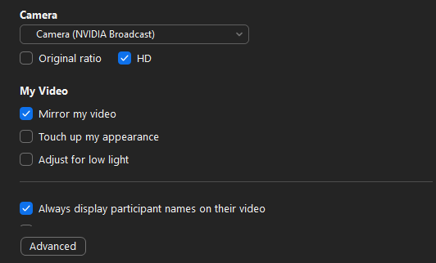

Click on the dropdown box underneath Camera header and make sure you have the right camera selected. If you are unsure as to which option is your camera, you can cycle through the list by clicking on each one and seeing if your video eventually comes up.

**Not Logged into a Zoom Account**

While in a meeting, click on the up arrow located right beside the Video option.

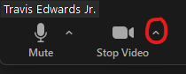

Select your camera in the box that appears. If you are unsure as to which option is your camera, you can cycle through the list by clicking on each one and seeing if your video eventually comes up.

**Note:** You can also press Alt + N to cycle through cameras during a meeting.

**If you are still experiencing camera issues after attempting these steps please submit a ticket.**

### 

### Microphone and\or Speaker is not working:

**Logged into a Zoom Account**

Click on the Audio section of the settings menu, this should bring up all the settings related to your speaker and microphone. Make sure your correct Speaker and Microphone are selected, if you are unsure which is the correct option you can cycle through each option. After clicking an option you can select the Test Speaker or Test Mic button to see if it is working now.

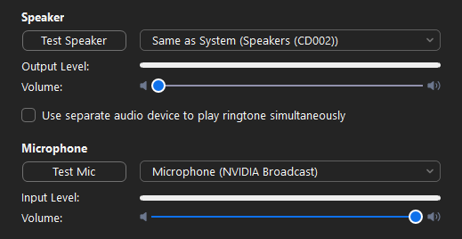

Also make sure the volume sliders are turned up otherwise you may have the correct mic/speaker selected but testing it will still not work.

**Not Logged into a Zoom Account**

While in a meeting, click on the up arrow located right beside the Mic option.

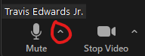

Click on the Test Speaker & Microphone option. This will bring up a dialog box to help with cycling through and finding the correct speaker and microphone. Follow the instructions and this should resolve any audio issue you may be experiencing.

**Note:**Make sure your computer volume is also turned up if you are experiencing speaker problems. You can check this by click on the speaker icon at the bottom right hand corner of your main display.

mceclip4.png

**If you are still experiencing audio issues after attempting these steps please submit a ticket.**

You can submit a request at: https://mywinterhaven.zendesk.com/hc/en-us/requests/new